**附件1**

本市汰換補助申請據點：

| 序號 | 公司名稱 | 地址 | 電話 | 連絡人 |
| --- | --- | --- | --- | --- |
| 1 | 高興能源股份有限公司 | 新北市新店區安康路3段628號 | 02-22152516 | 王海文先生 |
| 2 | 北誼興業股份有限公司（樹林場） | 新北市樹林區山佳里新興街34號 | 02-26806104 | 楊來發先生 |
| 3 | 北陽興業股份有限公司 | 新北市林口區嘉寶里嘉溪雅坑1鄰5-7號 | 02-26051268 | 呂宏圖先生 |
| 4 | 銘欣能源股份有限公司 | 新北市林口區嘉寶里嘉溪雅坑5號之4 | 02-26051290 | 許宏華先生 |
| 5 | 嘉浩實業股份有限公司 | 新北市林口區嘉寶里嘉溪雅坑3-6號 | 02-26051261 | 胡祥瑞先生 |

**附件2**



**附件3**

新購容器基本資料清冊

申請月份： 年 月

分銷商名稱：

分銷商統一編號：

|  |  |  |  |  |  |
| --- | --- | --- | --- | --- | --- |
| 序號 | 合格標示號碼 | 容器號碼 | 規格 | 出廠耐壓日期 | 定期檢驗日期 |
|  |  |  |  |  |  |
|  |  |  |  |  |  |
|  |  |  |  |  |  |
|  |  |  |  |  |  |
|  |  |  |  |  |  |
|  |  |  |  |  |  |
|  |  |  |  |  |  |
|  |  |  |  |  |  |
|  |  |  |  |  |  |
|  |  |  |  |  |  |
|  |  |  |  |  |  |
|  |  |  |  |  |  |
|  |  |  |  |  |  |
|  |  |  |  |  |  |
|  |  |  |  |  |  |
|  |  |  |  |  |  |
|  |  |  |  |  |  |
|  |  |  |  |  |  |
|  |  |  |  |  |  |
| 分銷商公司(行號)章 | | | | | |
|  | | | | | |

**請上申報網站：**

**1.網站名稱：內政部消防署液化石油氣零售業者營運資料申報暨容器管理系統(網址：http://210.69.173.51/)，註冊/登入所屬帳號。**

**2.辦理營運資料申報後，每次辦理申請汰換容器補貼時，均應自營運資料申報網站製作及列印下列申請文件，據以辦理汰換容器補貼申請**

**附件4**

淘汰容器基本資料清冊(淘汰容器監毀證明)

申請月份： 年 月

分銷商名稱：

分銷商統一編號：

|  |  |  |  |  |  |  |
| --- | --- | --- | --- | --- | --- | --- |
| 序號 | 合格標示號碼 | 容器號碼 | 規格 | 出廠耐壓日期 | 定期檢驗日期 | 下次檢驗日期 |
|  |  |  |  |  |  |  |
|  |  |  |  |  |  |  |
|  |  |  |  |  |  |  |
|  |  |  |  |  |  |  |
|  |  |  |  |  |  |  |
|  |  |  |  |  |  |  |
|  |  |  |  |  |  |  |
|  |  |  |  |  |  |  |
|  |  |  |  |  |  |  |
|  |  |  |  |  |  |  |
|  |  |  |  |  |  |  |
|  |  |  |  |  |  |  |
|  |  |  |  |  |  |  |
|  |  |  |  |  |  |  |
|  |  |  |  |  |  |  |
|  |  |  |  |  |  |  |
|  |  |  |  |  |  |  |
| 汰換據點管轄消防分隊章  (監毀後用印) | | | | 分銷商公司(行號)章 | | |
|  | | | |  | | |

**請上申報網站：**

**1.網站名稱：內政部消防署液化石油氣零售業者營運資料申報暨容器管理系統(網址：http://210.69.173.51/)，註冊/登入所屬帳號。**

**2.辦理營運資料申報後，每次辦理申請汰換容器補貼時，均應自營運資料申報網站製作及列印下列申請文件，據以辦理汰換容器補貼申請**

**附件5**

簽定家用液化石油氣供氣定型化契約證明

查　 (商號)

（營業地址：新北市 區 ）為辦理　　年　　月份液化石油氣容器汰換補助申請案，經查已簽訂之「家用液化石油氣供氣定型化契約」共計 份，並依消防法第15條之2規定，於「內政部消防署液化石油氣零售業者營運資料申報暨容器管理系統」完成電子申報工作。

此證

新北市政府消防局第 大隊 分隊

分隊圓戳章

承辦人：　　　　　　　　　　單位主管：

中 華 民 國 年 月 日

**附件6**

液化石油氣容器汰換補助款申請單

|  |  |  |  |  |  |  |  |  |  |  |  |  |  |  |  |  |  |  |  |  |  |  |  |  |  |  |  |  |  |  |  |  |  |  |  |  |  |  |  |  |  |  |  |  |  |  |  |  |  |  |  |  |  |  |  |  |  |  |  |
| --- | --- | --- | --- | --- | --- | --- | --- | --- | --- | --- | --- | --- | --- | --- | --- | --- | --- | --- | --- | --- | --- | --- | --- | --- | --- | --- | --- | --- | --- | --- | --- | --- | --- | --- | --- | --- | --- | --- | --- | --- | --- | --- | --- | --- | --- | --- | --- | --- | --- | --- | --- | --- | --- | --- | --- | --- | --- | --- | --- |
| 收件日期 | 年 | | 月 | | | | | | 日 | | | | | | NO.01 | | | | | | | | | | | | | | | | | | | | | | | | | | | | | | | | | | | | | | | | | | | | |
| 汰換據點名稱 | 公司 | | | | | | | | | | | | | | | | | | | | | | | | | | | | | | | | 代號 | | | | | |  | | | | |  | | | | | |  | |  | | |  | | | |  |
| 零售業名稱(全銜) |  | | | | | | | | | | | | | | | | | | | | | | | | | | | 統一  編號 | | | | |  | |  | | | | |  | | | | |  | | | | |  | |  | | |  | | |  | |
| 零售業地址 |  | | | | | | | | | | | | | | | | | | | | | | | | | | | | | | | | | | | | | | | | | | | | | | | | | | | | | | | | | | |
| 應備文件 | □1.「經濟部公司登記事項卡」及「核准函」 □7.淘汰容器監毀證明文件。  或縣(市)政府核發之「商業抄錄本」影本。 □8.上月新購容器發票及其基本資料清冊。  □2.最近一期「營業人銷售額與稅額申報書」。 □9.消防分隊核發之「供氣契約」證明文件。  □3.公共意外責任險投保收據影本。 □10.匯款銀行存摺正面影本。  □4.液化石油氣容器儲存場所證明文件影本。 □11.補助款發票。  □5.液化石油氣上月灌氣發票。 □12.內政部消防署退件公文影本。(退件重新  □6.申請汰換之容器基本資料清冊。 申請者，須檢附) | | | | | | | | | | | | | | | | | | | | | | | | | | | | | | | | | | | | | | | | | | | | | | | | | | | | | | | | | | |
| 供氣合約證明 | 核發年月 | | | | | | | 年 | | | | | | | | | 月 | | | | | | 合約戶數 | | | | | | | | | | | | | 計 戶。 | | | | | | | | | | | | | | | | | | | | | | | |
| 淘汰容器數量 | 規格 | | | | | | | 50kg | | | | | | | | 20kg | | | | | | | 16kg | | | | | 10kg | | | | | | | | 4kg | | | | | | | | | | | | | 合計 | | | | | | | | | | |
| 數量(支) | | | | | | |  | | | | | | | |  | | | | | | |  | | | | |  | | | | | | | |  | | | | | | | | | | | | |  | | | | | | | | | | |
| 上月灌氣  發票資料 | 年 | 月 | | | 分 裝 場 統 一 編 號 | | | | | | | | | | | | | | | | | | | | | | | 灌裝量(公斤) | | | | | | | | | | | | | | | | | | | | | | | | | | | | | | | |
|  |  | | |  | |  | | | | |  | |  | | | |  | |  | | | |  | |  | |  | | | |  | | | | |  | | | | | | | | |  | | | | |  | | | | |  | | | |
|  |  | | |  | |  | | | | |  | |  | | | |  | |  | | | |  | |  | |  | | | |  | | | | |  | | | | | | | | |  | | | | |  | | | | |  | | | |
|  |  | | |  | |  | | | | |  | |  | | | |  | |  | | | |  | |  | |  | | | |  | | | | |  | | | | | | | | |  | | | | |  | | | | |  | | | |
|  |  | | |  | |  | | | | |  | |  | | | |  | |  | | | |  | |  | |  | | | |  | | | | |  | | | | | | | | |  | | | | |  | | | | |  | | | |
| 合 計 | | | | | | | | | | | | | | | | | | | | | | | | | | |  | | | |  | | | | |  | | | | | | | | |  | | | | |  | | | | |  | | | |
| 總灌裝量 | | | | 公噸 | | | | | | | | | | | | | | | | | | | | | | | 汰換額度量 | | | | | | | | | | | | | | 支 | | | | | | | | | | | | | | | | | |
| 上月新購  容器發票  資料 | 年 | 月 | | | 新瓶供應商統一編號 | | | | | | | | | | | | | | | | | | | | | | | 容器規格(支) | | | | | | | | | | | | | | | | | | | | | | | | | | | | | | | |
| 50kg | | | | | 20kg | | | | | | | | 16kg | | | | | | | | | 10kg | | | | | 4kg | | | | |
|  |  | | |  | |  | | | | |  | |  | | | |  | |  | | | |  | |  | |  | | | | |  | | | | | | | |  | | | | | | | | |  | | | | |  | | | | |
|  |  | | |  | |  | | | | |  | |  | | | |  | |  | | | |  | |  | |  | | | | |  | | | | | | | |  | | | | | | | | |  | | | | |  | | | | |
|  |  | | |  | |  | | | | |  | |  | | | |  | |  | | | |  | |  | |  | | | | |  | | | | | | | |  | | | | | | | | |  | | | | |  | | | | |
| 上月新購容器各規格數量小計 | | | | | | | | | | | | | | | | | | | | | | | | | | |  | | | | |  | | | | | | | |  | | | | | | | | |  | | | | |  | | | | |
| 上月新購容器總數量 | | | | | | | | | | | | | | | | | | | | | | | | | | | 支 | | | | | | | | | | | | | | | | | | | | | | | | | | | | | | | |
| 零售業  匯款銀行  帳號 | 戶名： | | | | | | | | | | | | | | | | | | | | | | | | | | | 銀行名稱 | | | | | | | | | | | | | | | 銀行 | | | | | | | | | | | | | | | | |
| 銀行代號 | | |  | |  | | | | |  | | 帳 號 | | | | | |  | | |  | | |  | |  |  | | |  | | |  | | | |  | | | | |  | | | | |  | | |  | |  | | | |  | | | |
| 可汰換容器補貼  數量及金額表 | | | | | | | | | | 規格 | | | | | | | | | | | 50kg | | | | | 20kg | | | | 16kg | | | | | | | 10kg | | | | | | | | | | 4kg | | | | | | | 合計 | | | | | |
| 補貼數量(支) | | | | | | | | | | |  | | | | |  | | | |  | | | | | | |  | | | | | | | | | |  | | | | | | |  | | | | | |
| 補貼金額 | | | | | | | | | | | 元 | | | | | | | | | | | | | | | | | | | | | | | | | | | | | | | | | | | | | | |
| 資 料 核 對 結 果 | | | | | | | | | | 汰 換 據 點 收 件 章 | | | | | | | | | | | | | | | | | | | 零 售 業 章 | | | | | | | | | | | | | | | | | | | | | | | | | | | | | | |
|  | | | | | | | | | |  | | | | | | | | | | | | | | | | | | |  | | | | | | | | | | | | | | | | | | | | | | | | | | | | | | |

註：一、紅框部分申請人勿填。

　　二、「零售業銀行帳戶之戶名」及「零售業章」須與零售業名稱完全相同。

三、資料核對無誤後，由容器協會先行墊付補助款，並將補助案送請內政部消防署審核，審核不通過者，申請人應返還補助款予容器協會。

**附件7**

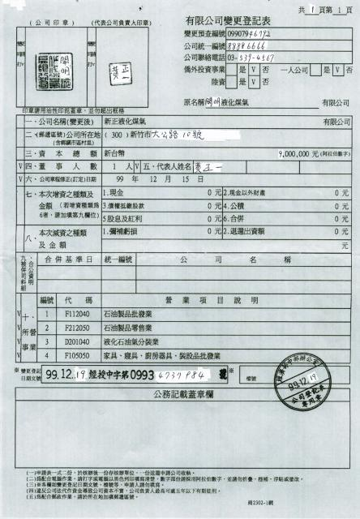

**附件8**

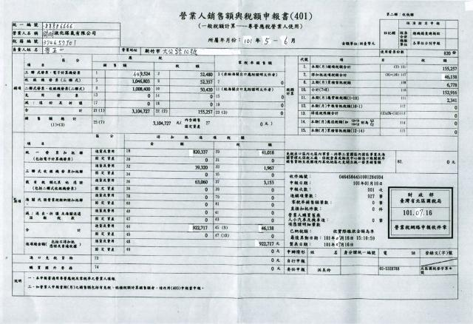

**附件9**

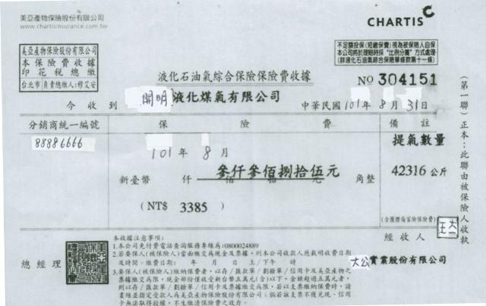

**附件10**

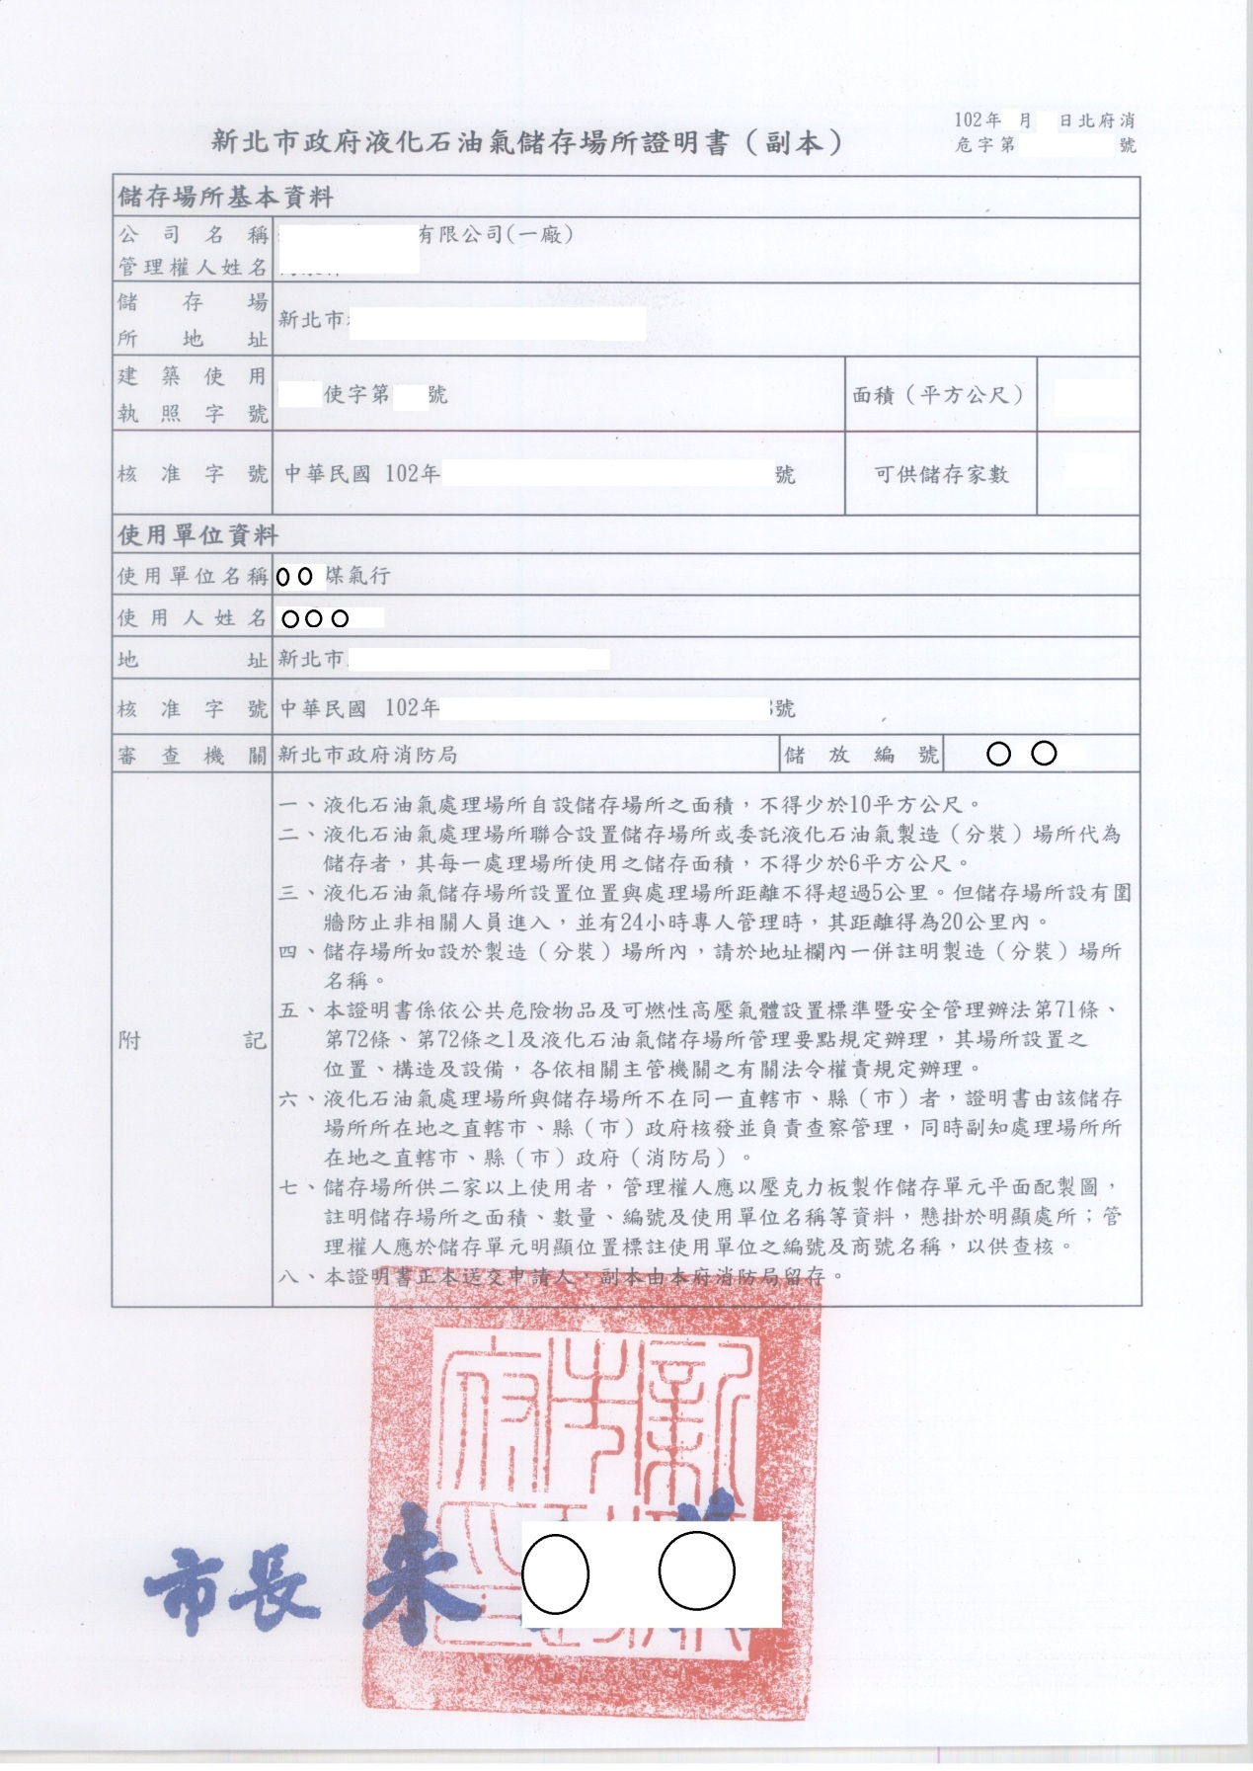

**附件11**

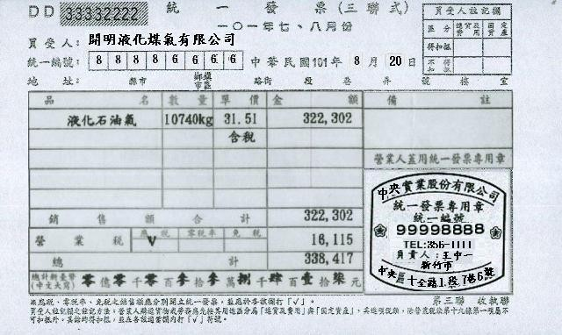

**附件12**

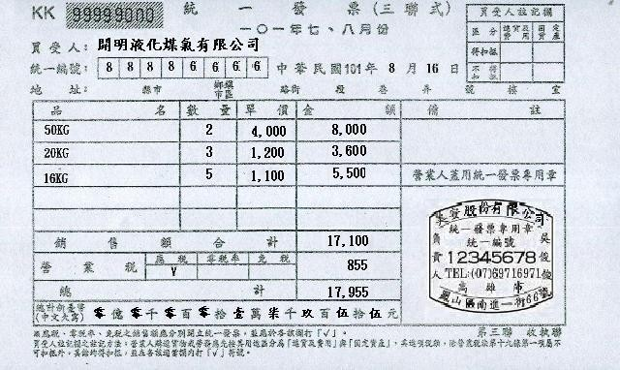

**附件13**

